GENERAL ADMISSIONS REQUIREMENTS

Students are accepted into the school on the basis of interest, motivation, academic background, and ability to benefit from the training offered. Students must be 17 years of age or older and have their high school diploma, GED, or pass an independently administered ability-to-benefit test.

FINANCIAL AID

Financial aid is available for those who qualify. Berk Trade and Business School offers the following:

AVAILABLE FINANCIAL AID PLANS
- Federal Pell Grants
- Federal Family Education Loans
- Federal Direct Loans
- ACCES-VR
- Job Re‐Training (UI TAA/TRA Grant)
- Veterans Administration Funding
- Americorps
- Employer sponsored tuition reimbursement
plans
- Flexible self-pay payment plans

In order to be eligible and qualify for financial aid assistance, students must be US citizens or eligible non-citizens. After an Admissions Representative conducts an initial interview, all applicants meet with the Financial Aid Officer in order to determine student eligibility to participate in the Federal aid programs.

BERK TRADE AND BUSINESS SCHOOL
33-09 QUEENS BOULEVARD
LONG ISLAND CITY, NEW YORK 11101

BERK TRADE
AND
BUSINESS SCHOOL

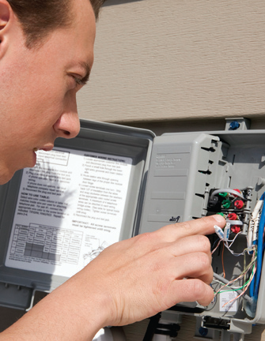
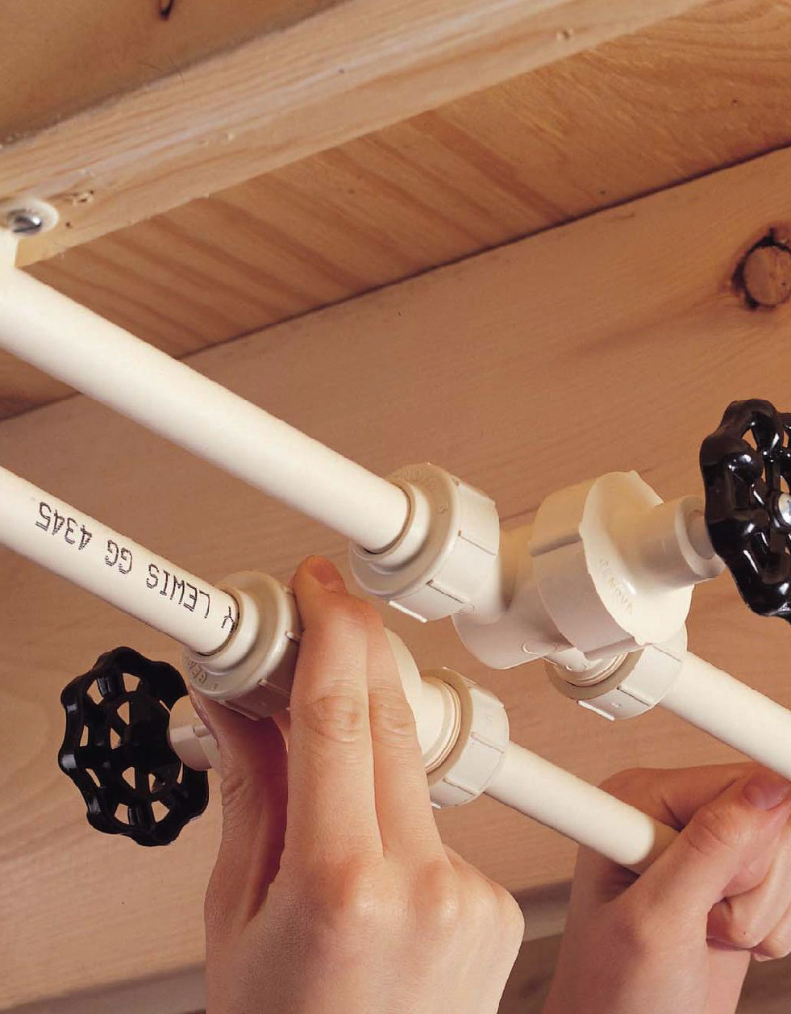

VOCATIONAL TRADE BROCHURE

600 HOUR PROGRAMS
33-09 Queens boulevard
Long island city, new yoRK 11101
Tel: (718) 729-0909
Fax: (718) 729-0606

WWW.ELECTRICALPLUMBINGCOURSE.COM
 LIKE us on:
Facebook.com/Berk Trade and Business School

 FOLLOW us on Twitter
@BerkTradeSchool


BERK TRADE AND
BUSINESS SCHOOL

HISTORY

Established in 1940, Berk Trade and Business School offers high quality training in the building trades specifically Electrical Installation and Comprehensive Plumbing. We have trained thousands of students from the New York area, other states, and most foreign countries. The school is licensed by the New York State Education Department, and accredited by the Accrediting Commission of Career Schools and Colleges.

600-HOUR COURSE DESCRIPTIONS
ELECTRICAL INSTALLATION

This course builds skills in the basic principles and working concepts along with practical hands on training critical to the electrical field. It covers the history of the trade, safety, use and care of tools, AC theory, drawing and blueprint reading, service entrance and circuit calculations, generators, motors, transformers and magnetic controls, illumination display, cable conduit installation, and general troubleshooting. These are the skills needed for success. Upon successful completion of this course, the student will be qualified for entry-level employment as an electrician's apprentice.

COMPREHENSIVE PLUMBING

This course builds skills in the basic principles and working concepts critical to the plumbing profession. It covers the history of the trade, safety, use and care of tools, sewage systems, and the New York City plumbing code. Related mathematics, sciences, blueprint reading, and shop projects are integral components of this course as well. These are the skills needed for success. Upon successful completion of this course, the student will be qualified for entry-level employment as a plumber's apprentice.

COURSE HOURS

Monday to Friday 9:00 am to 1:00 pm
Monday to Friday 1:00 p.m. to 5:00 pm
Monday to Friday 6:00 pm to 10:00 pm
Saturday & Sunday 9:00 am to 4:30 pm

GENERAL FACILITY AND EQUIPMENT

The School’s courses are taught in both classroom and shop environments to maintain a balance between theory and hands-on instruction. About 75% of each program is hands on. The shops are fully equipped with the necessary machinery, equipment, and tools of the trade.

The facility is designed to accommodate students comfortably. Classrooms are equipped to seat a maximum of 20 students. Laboratories accommodate a maximum of 20 students.

COURSE COMPLETION

Upon successful completion of the course, students earn a diploma. In order to qualify for graduation, a student must achieve passing grades (2.0 GPA), satisfactory attendance, and meet all financial requirements.

OBSERVED LEGAL HOLIDAYS

The school is closed on the following holidays when they are observed: New Year's Day, Martin Luther King Day, Presidents’ Day, Memorial Day, Independence Day, Labor Day, Columbus Day, Veterans’ Day, Thanksgiving Day, and Christmas Day.

PLACEMENT ASSISTANCE

Berk Trade and Business School is actively engaged in providing placement assistance for all graduates. The school maintains and updates an ongoing list of prospective employers who have hired our graduates. This list is constantly growing. Placement assistance is available anytime the graduate requests it. While placement assistance is available, it is understood that Berk Trade and Business School does not guarantee or promise employment.

TRANSPORTATION

SUBWAY: 7 Train – 33rd Street Station (at Queens Boulevard)
BUSES: Q32 or Q60 to 36th Street and Queens Boulevard.

Berk Trade and Business School has a rolling admissions policy. Classes typically begin every six to eight weeks.

Please call today to schedule an interview with a qualified admissions representative who will talk with you about your future goals.

(718) 729-0909

We look forward to meeting you soon!

Sincerely,
Your Berk Trade and Business School Team

